To Install Pusher:

1. Go to pusher site [pusher](https://pusher.com/) and click to Sign up to create account or Sign in to login if you have already account.
2. Create new app and fill the form data

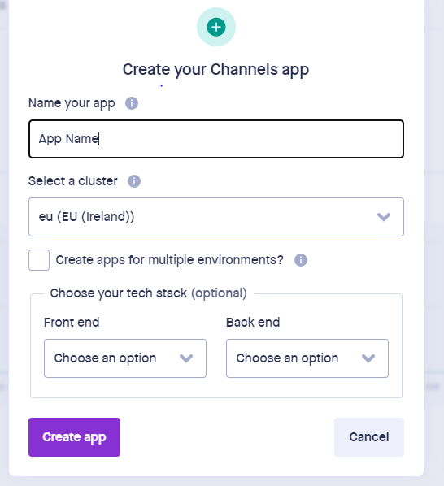

* Your app name.
* Your cluster area
* Your frontend language or framework.
* Your backend language or framework.

1. Install pusher server && laravel echo

npm install --save-dev laravel-echo pusher-js

1. Update your env file:

* Change **BROADCAST_DRIVER** value to **pusher**.
* Add your

**PUSHER_APP_ID**

**PUSHER_APP_KEY**

**PUSHER_APP_SECRET**

**PUSHER_APP_CLUSTER**

**Ex =>**

PUSHER_APP_ID=1403548

PUSHER_APP_KEY=8a54692d8cd3a078d328

PUSHER_APP_SECRET=20a9db67b966ea5ba2ff

PUSHER_HOST=

PUSHER_PORT=443

PUSHER_SCHEME=https

PUSHER_APP_CLUSTER=eu

VITE_PUSHER_APP_KEY="${PUSHER_APP_KEY}"

VITE_PUSHER_HOST="${PUSHER_HOST}"

VITE_PUSHER_PORT="${PUSHER_PORT}"

VITE_PUSHER_SCHEME="${PUSHER_SCHEME}"

VITE_PUSHER_APP_CLUSTER="${PUSHER_APP_CLUSTER}"

* And all this values can get it from **App Keys** page in your pusher profile.

1. In config /app.php , uncomment this line

App\Providers\BroadcastServiceProvider::class

1. In **boot** method in **BroadcatServiceProvider** class append this lines:

        Broadcast::routes();

*require* base_path('routes/channels.php');

1. In config/broadcasting.php change:

'options' => [

'cluster' = **PUSHER_APP_CLUSTER**,

'useTLS' => true

],

1. In ***resources/js/ bootstrap.js*** file uncomment for this code

*import* Echo *from* 'laravel-echo';

*import* Pusher *from* 'pusher-js';

window.Pusher = Pusher;

window.Echo = new Echo({

    broadcaster: 'pusher',

    key: *import*.meta.env.VITE_PUSHER_APP_KEY,

    cluster: *import*.meta.env.VITE_PUSHER_APP_CLUSTER,

    wsHost: *import*.meta.env.VITE_PUSHER_HOST ?? `ws-${*import*.meta.env.VITE_PUSHER_APP_CLUSTER}.pusher.com`,

    wsPort: *import*.meta.env.VITE_PUSHER_PORT ?? 80,

    wssPort: *import*.meta.env.VITE_PUSHER_PORT ?? 443,

    forceTLS: (*import*.meta.env.VITE_PUSHER_SCHEME ?? 'https') === 'https',

    enabledTransports: ['ws', 'wss'],

});

1. Then you can create event using this command

**php artisan make:event {MyEven}**

1. Channels type

- Channel class to create public channel => (my-channel)

- PrivateChannel class to create private channel => (my-channel.{UserID})

1. In master blade must include public/js/app.js file to can use window.Echo
2. Run this command **npm run watch** to make compile for app.js
3. To make listen using this code

 window.Echo.channel(`private-my-channel.${userID}`)

     .listen('MyEvent', (data) => {

alert(data);

     });

1. For private channel must make channel to return auth details in routes/channel.php

Broadcast::channel('my-channel.{id}', function ($user, $id) {

*return* (int) $user->id == (int) $id ? $user : null;

});

Must return user details not true or false

1. For public channel not need to create channel route because broadcast for all users.
2. This example for create **MessageCreated** Event that have private channel new-message with append user id

<?php

namespace App\Events;

use Illuminate\Broadcasting\Channel;

use Illuminate\Broadcasting\InteractsWithSockets;

use Illuminate\Broadcasting\PresenceChannel;

use Illuminate\Broadcasting\PrivateChannel;

use Illuminate\Contracts\Broadcasting\ShouldBroadcast;

use Illuminate\Foundation\Events\Dispatchable;

use Illuminate\Queue\SerializesModels;

class MessageCreated implements ShouldBroadcast

{

    use Dispatchable, InteractsWithSockets, SerializesModels;

*/\*\**

*\* Create a new event instance.*

*\**

*\* @return void*

*\*/*

    public function __construct(public Message $message, public int $user_id)

    {

*//*

    }

*/\*\**

*\* Get the channels the event should broadcast on.*

*\**

*\* @return \Illuminate\Broadcasting\Channel|array*

*\*/*

    public function broadcastOn()

    {

*return* new PrivateChannel("new-message.{*$this*->user_id}");

    }

}

1. Example for fire event MessageCreated

                broadcast(new MessageCreated($Message, $recevier_id));

1. Example for event listen in blade

        <script>

            $(function() {

const AUTH_USER_ID = {{ auth()->id() }};

                Echo.channel(`private-new-message.${AUTH_USER_ID}`)

                .listen('MessageCreated', (data) => {

                    alert(data);

                });

            });

        </script>

1. How to detect user is online or Ofline

window.Echo.join(`chat`)

           .joining((user) => { *// This user is join to chat page*

               console.log(user);

           })

           .leaving((user) => { *// This user is leaving to chat page*

               console.log(user);

           })

1. And add this channel to get user details

Broadcast::channel('chat', function ($user) {

*return* $user;

});

1. To use typing

- First must make enable for pusher client events from **App Setting** and make enable to **Enable client events.**

- For char channel in last step add new listener on **whisper typing event**

    let chatChannel = window.Echo.join(`chat`)

                            .listenForWhisper('typing', (e) => {

                                If (e.typing)

Do something when typing

Else

Do something after stop

                            });

And save the result in object to use it in another place.

1. Make js event on input and use the last object to make event **whisper typing**

    let time = false;

    $('body').on('keydown', '[name="message"]', function(){

        chatChannel.whisper('typing', {

            typing: true,

        });

*if* (time) clearTimeout(time);

        time = setTimeout( () => {

            chatChannel.whisper('typing', {

                typing: false,

            });

        }, 600);

    });